Known Issues / To-do

Known Issues

1. In desktop view, the plants are in a jumbled paragraph
2. Messing with Bed URL will change the bed’s drop-down
3. Some uncaught error

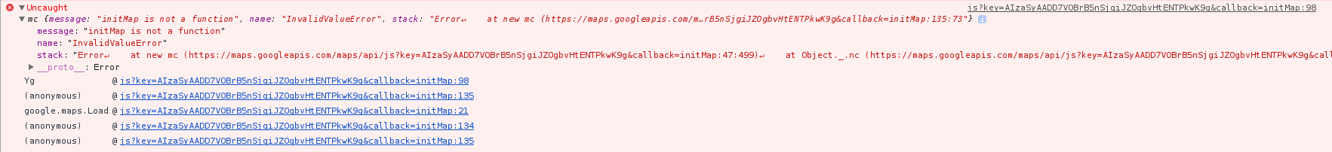

To-do

1. Implement back buttons (for when clicking on a plant from Search)
2. When clicking on a plant, bring the plant info to the top of the page (desktop view only)
3. Implementing restriction on how long of a comment someone could leave